The Daily News – Newspaper Website

1. Project Overview
This project is a student newspaper website created using HTML5, CSS, and JavaScript.
The purpose of the website is to demonstrate web development skills including layout design, navigation, responsive design, and interactive features.
The website contains multiple pages including a home page, history page, contact page, and about page. It is designed as a simple news website to display articles, images, and multimedia content in a structured format such as what was instructed by the checklist.

2. Website Pages
The website includes the following pages:
- Home Page (index.html) – Displays news cards, welcome message, and featured content.
- History Page (history.html) – Shows the history of newspapers with images and a video.
- Contact Page (contact.html) – Includes a contact form and Google Maps location.
- About Page (about.html) – Provides information about the project and includes lists.

3. additional Feature
A simple JavaScript function was added to allow users to toggle between light mode and dark mode.
This improves user experience and demonstrates basic DOM manipulation.

4. Images and Media
All images used are either public domain or educational placeholders for academic use.
The website also includes:
- Images in news cards
- A floated image on history page
- A video file on the history page

Sources: Wikipedia and vecteezy

5. Design Choices
The design focuses on:
- Clean layout
- High contrast for readability
- Consistent spacing and alignment
- Simple navigation for usability
The layout follows a newspaper-style structure with sections and cards to organize content clearly.

6. Validation
The website was tested using W3C validation tools:
https://validator.w3.org/
Any errors found during development were corrected to ensure proper HTML5 and CSS standards.
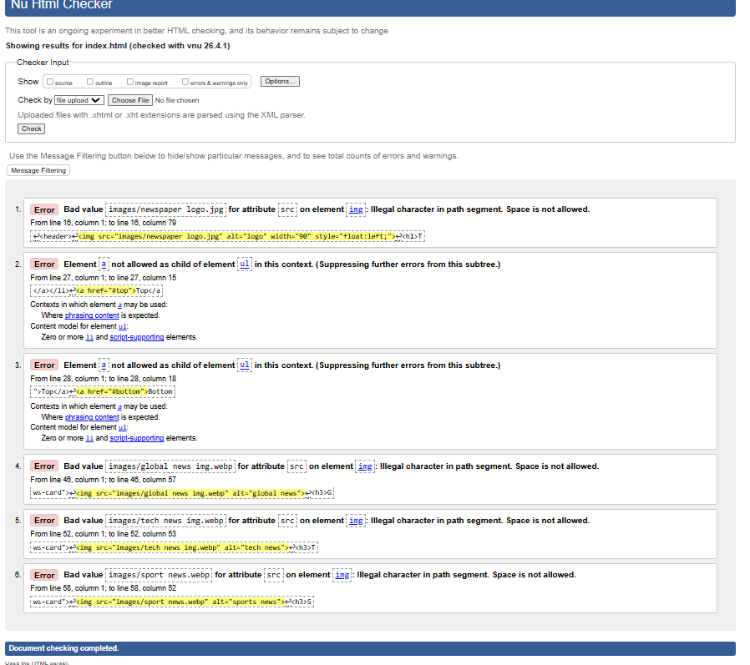
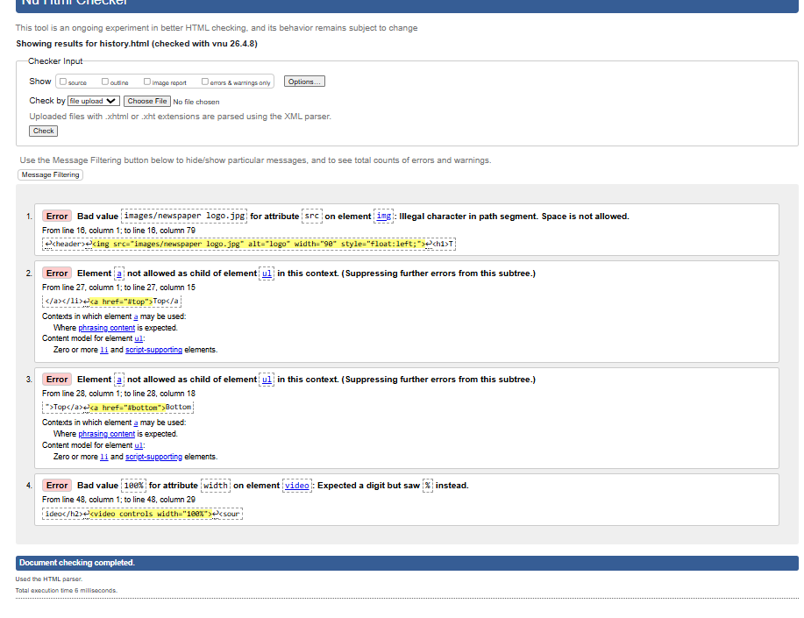
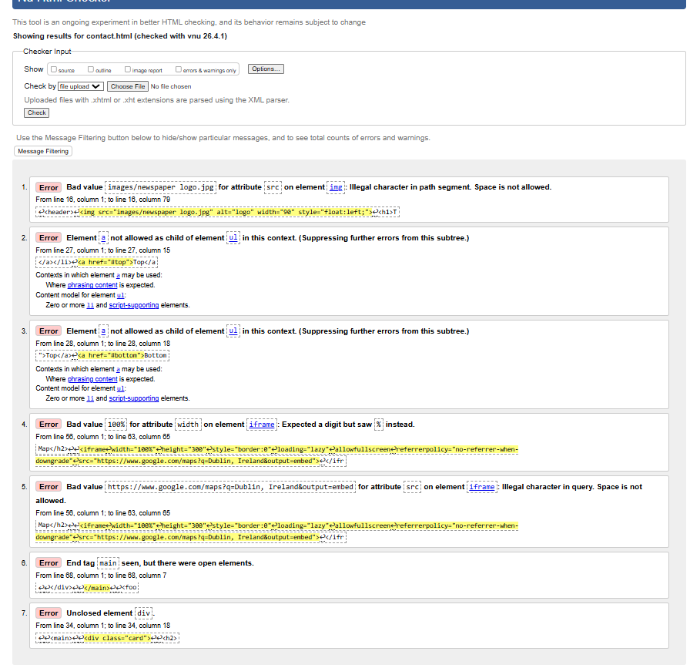
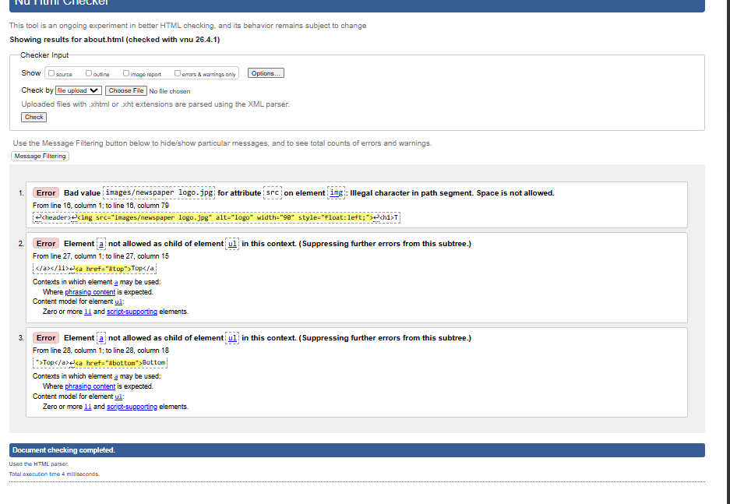

7. Challenges
Some challenges included:
- Aligning layout across multiple pages
- Fixing navigation consistency
- Embedding Google Maps correctly
- Ensuring responsive design worked on smaller screens
- Had a problem with the video
- Logo alignment
- CSS for light and dark mode

8. Conclusion
This project successfully demonstrates the use of HTML5, CSS, and JavaScript to build a functional multi-page website. The final result is a responsive and structured newspaper-style website that meets all assignment requirements and is created to look clean and be able to be easily operated.

9. Declaration
I confirm that this project is my own work and has been created for educational purposes.
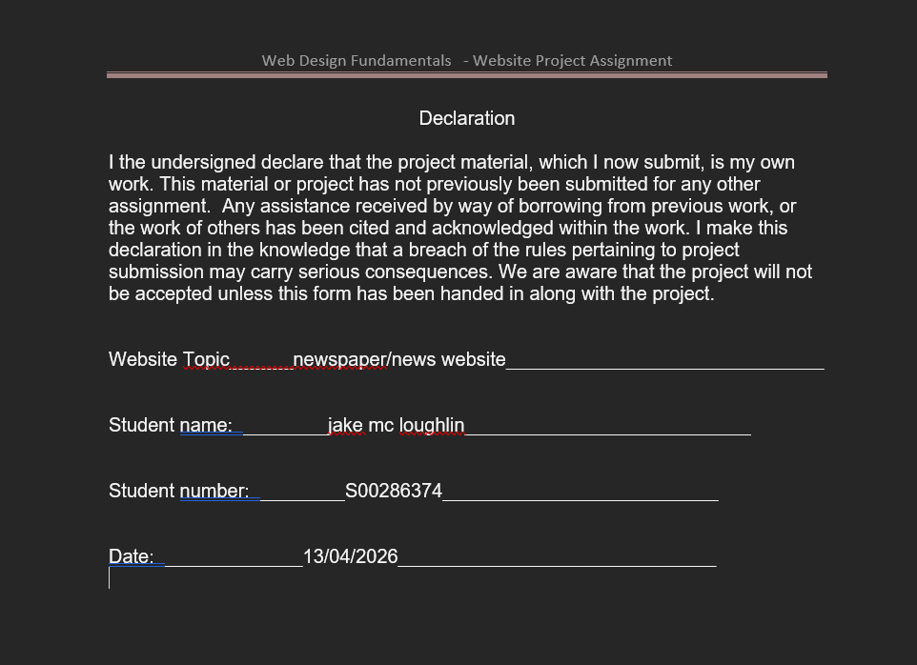

Initial sketch

